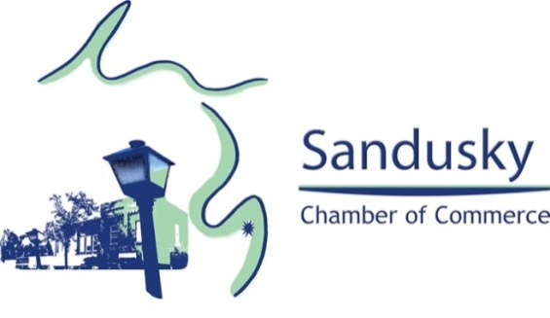

Sandusky Chamber of Commerce
MEMBERSHIP APPLICATION
WORKING TOGETHER TO SERVE YOU…TODAY AND IN THE FUTURE

Name of Business:
Address:
City: State: Zip: Phone: Website:
Primary Contact: Email: Secondary Contact: Email:

Would you like to be contacted to help in planning either one or both of our annual events:
26th Annual Lighted Implement Parade (12/7/19) Thumb Festival Weekend (6/25-6/28/20)

Some Members have expressed wanting the opportunity to do one check for membership and festival sponsorships. If you would like to do so please complete sponsorship information on the back side of membership form.

Total Enclosed:

Thumb Festival Sponsorship

Country Christmas Weekend

2019/20 Annual Membership Dues - $100

Make Check Payable to: SANDUSKY CHAMBER OF COMMERCE

Send Completed Form and Payment to: Sandusky Chamber of Commerce
c/o Northstar Bank
665 S. Sandusky Rd., Ste 3
Sandusky, MI 48471

Sponsorship Packages for the 26th Annual Country Christmas Weekend:

DIAMOND SPONSORSHIP – 1 1/2’ x 2’ Proud Sponsor sign to place at $200
your business along with Radio Ad mentions, recognition on Facebook, and
listed as a sponsor in the newspaper.

GOLD SPONSORSHIP – 1 1/2’ x 2’ Proud Sponsor sign to place at your $150
business along with Radio Ad mentions and recognition on Facebook.

SILVER SPONSORSHIP – 1 1/2’ x 2’ Proud Sponsor sign to place at your $100
business along with recognition on Facebook.

Sponsorship Packages for 2020 Thumb Festival Weekend

DIAMOND SPONSORSHIP – 2’ x 4’ sign to be placed on Courthouse $150
Lawn the week of Thumb Festival with your choice to add your logo at
no additional charge. You can email your logo directly to Stoliker’s
Custom Design at signs@stolikers.com (please note in your email that it’s
for the Chamber Sponsor Signs) or Joe Nartker can pick it up (810-648-4931).

GOLD SPONSORSHIP – 1 ½’ x 2’ sign to be placed on Courthouse Lawn the $75
week of the Thumb Festival.

Please indicate which sponsorship(s) you would like and include the cost on the front of the membership form.

Thank you for your support of these two major events held in Sandusky! Your support is greatly appreciated and is a major contributor in allowing the Chamber to continue holding these festivals every year!

